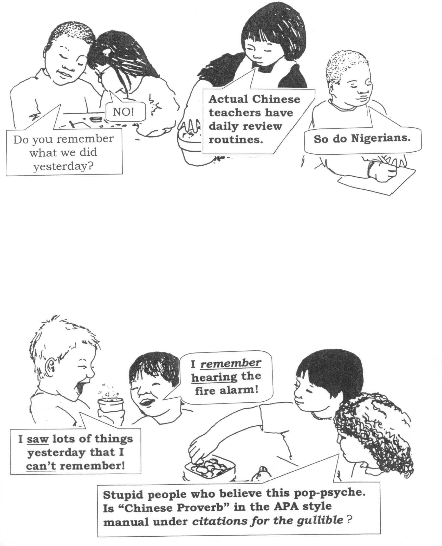
I HEAR, AND I FORGET (?)
I SEE, AND I REMEMBER (?)
I DO, AND I UNDERSTAND (?)

- CHINESE PROVERB (?)

